HISTORY:BUILDINGS , PAINTING AND BOOKS
1.What is a monolithic temple?
(a) Each of these was carved out of a huge, single piece of stone
(b) Each of these was carved out of a huge, two piece of stone
(c) Each of these was carved out of a huge, three piece of stone
(d) Each of these was carved out of a huge, many piece of stone
2. According to the Mahabharata, the war between the Kauravas and the Pandavas was fought to control which part?
(a) Mahabalipuram
(b) Aihole
(c) Hastinapur
(d) Sanchi
3. The Puranas contain stories about gods and goddesses, such as
(a) Vishnu, Shiva, Durga or Parvati
(b) Ganesh, Shiva, Gurunanak dev or Parvati
(c) Ganesh, Shiva, Durga or Gurunanak dev
(d) Vishnu, Shiva, Durga or Ganesh
4. What was the most important part of an ancient Hindu temple where the image of the chief deity was placed
(a) Shikhara
(b) Garbhagriha
(c) Madhyagriha
(d) Mundka
5. What is relic casket?
(a) Box contains remains of shudras
(b) Box contains remains of animals
(c) Box contains remains of Buddha
(d) Pillar which was having unique design
6.Assertion(A): There are several kinds of stupas but they all possess a common feature that stands out.
Reason(R): The word stupar means ‘mound’. Generally there is a small box placed at the centre or heart of the stupas. This may contain bodily remains of Buddha or his followers or things they used as well as precious stones and coins.

7. Assertion(A): Epics are grand long compositions about heroic men and women, and include stories about gods.
Reason(R): A famous Tamil epic, the Silappadikaram, was composed by a poet named Ilango around 1800 years ago.

8. Assertion(A): Stories from the Jatakas and Stupas were often shown on the railings of Stupas.
Reason(R): Ordinary people also told stories, composed poems and songs. Sang, danced and performed plays.

9. Which of the following statement is or are CORRECT?
Statement 1:The two famous practitioners of Ayurveda in ancient India were Charaka and Sushruta.
Statement 2: Valmiki is recognised as the author of the Sanskrit Ramayana.
Statement 3: At Bhitargaon in Uttar Pradesh a tower was built on top of the Sikharas , known as garbhagriha
A. Only Statement 1 is correct
B. Both Statement 1 and 2 are correct.
C. Only Statement 2 is correct
D. Statement 2 and 3 are correct

10.Ordinary people also told stories, composed poems and songs, which were preserved as _________ and ____________.
11. Meghaduta was written by _______.

SUBJECTIVE QUESTIONS:
12.What were the different stages in building a stupa or temple?
13. What are epics? Mention two famous Tamil epics which were written around 1800 years ago.
14. Explain the historical significance of the Iron Pillar at Mehrauli. What does it tell us about the technological advancements of ancient India.?
15. Identify the architectural features of the and explain its importance as a symbol of ancient Indian art and architecture.
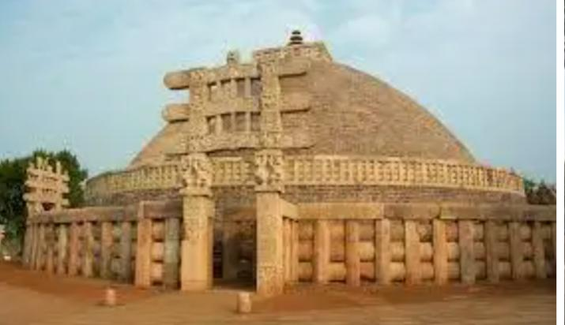
16. Aryabhata's work has influenced both Indian and global science. How did his mathematical theories, such as the value of zero, impact future generations?
17. Hint 1: I am an epic
Hint 2: I describe the story of Kauravas and Pandavas.
Who I am?

